**LAB 07 EX0**

**Website:** [**https://sidigital.co/**](https://sidigital.co/)

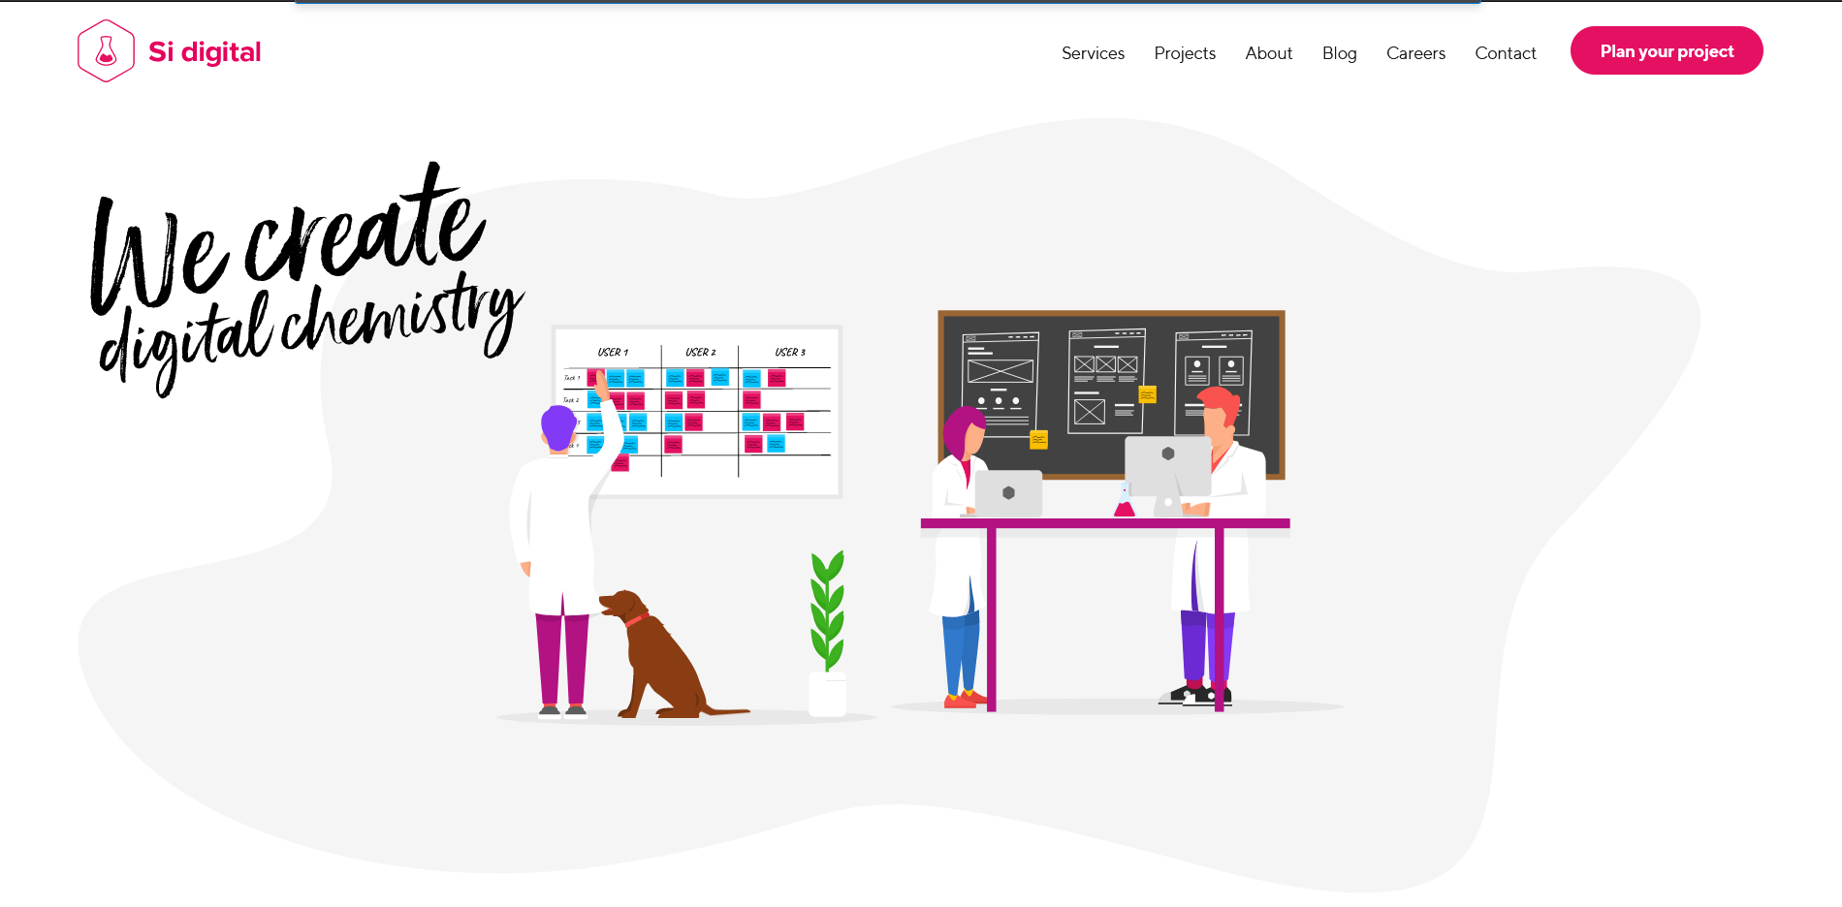

Elemente html: imagini, titlu.

Elemente css: Font text

Elemente JavaScript: animatii